1. Write a C program to check positive, negative or zero using simple if or if else.

C program to input any number from user and check whether the given number is positive, negative or zero. Logic to check negative, positive or zero in C programming.

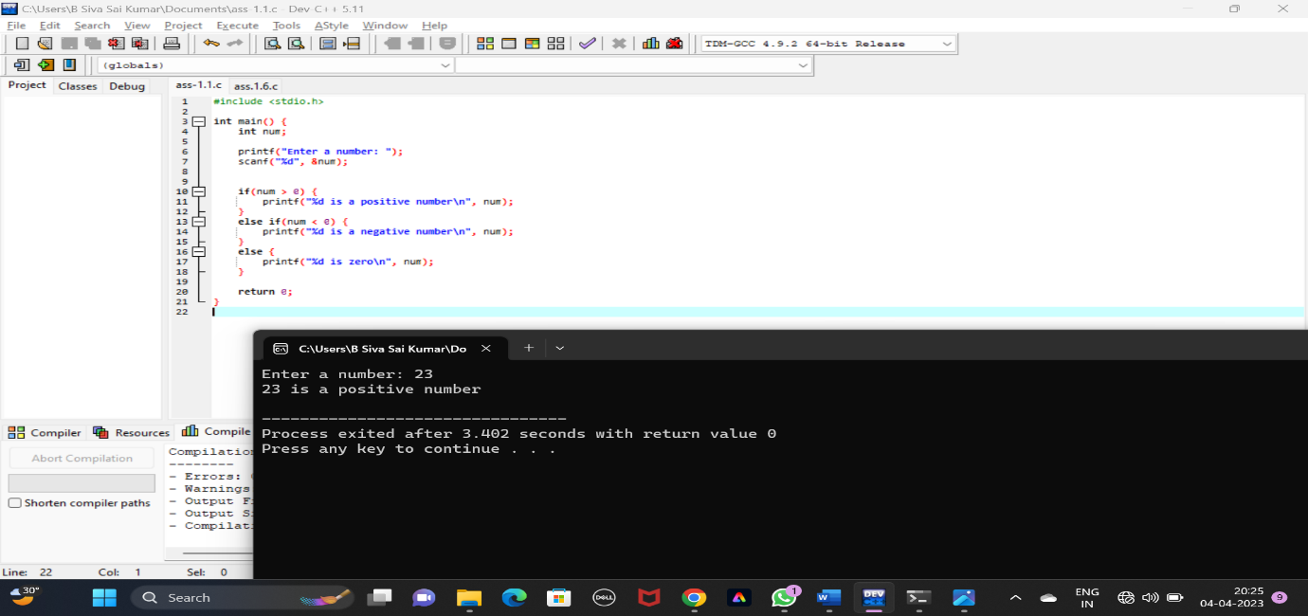

2.Write a C program to check whether a number is divisible by 5 and 11 or not using if else. How to check divisibility of any number in C programming. C program to enter any number and check whether it is divisible by 5 and 11 or not. Logic to check divisibility of a number in C program.

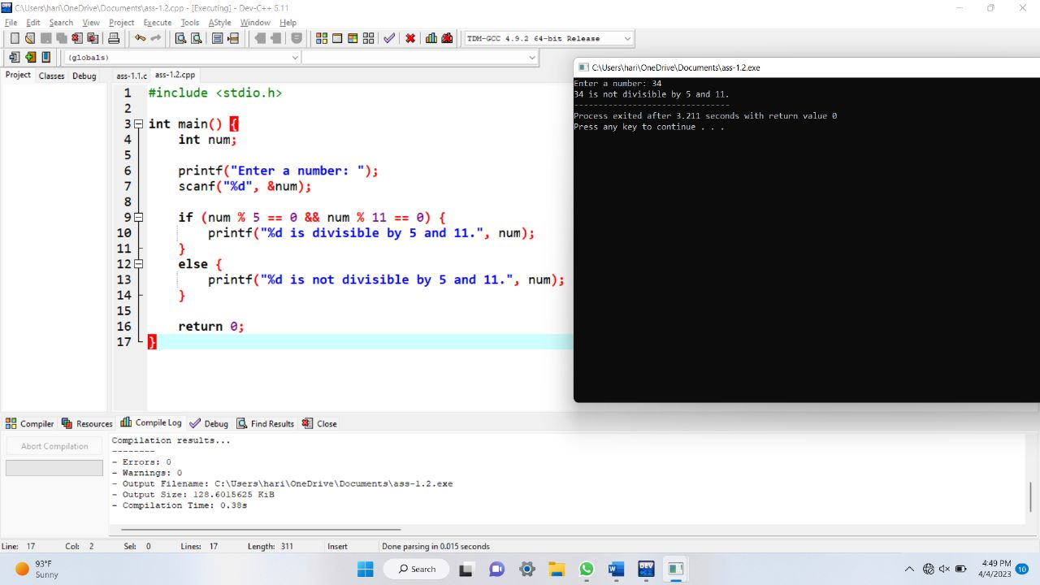

3.Write a C program to input a character from user and check whether the given character is alphabet or not using if else. How to check whether a character is alphabet or not in C programming. Logic to check if a character is alphabet or not in C program.

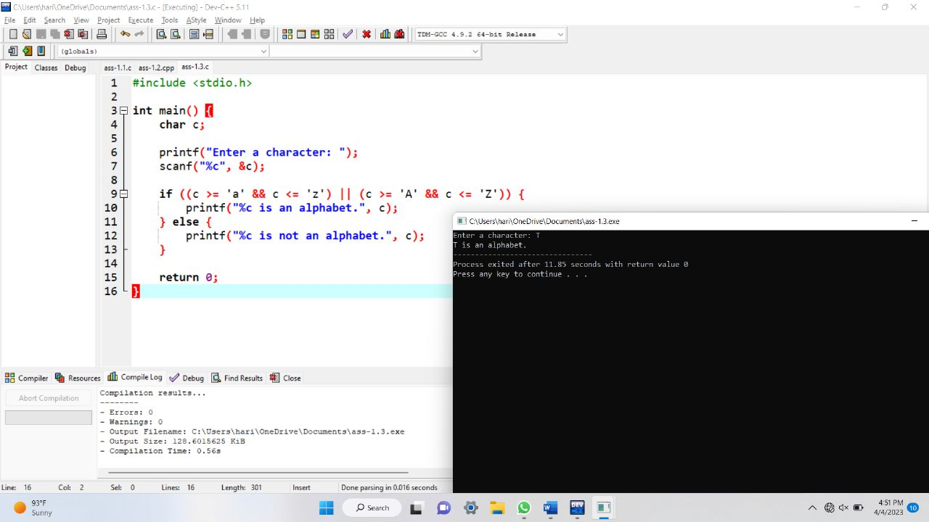

4.Write a C program to count the Vowels in the given string.

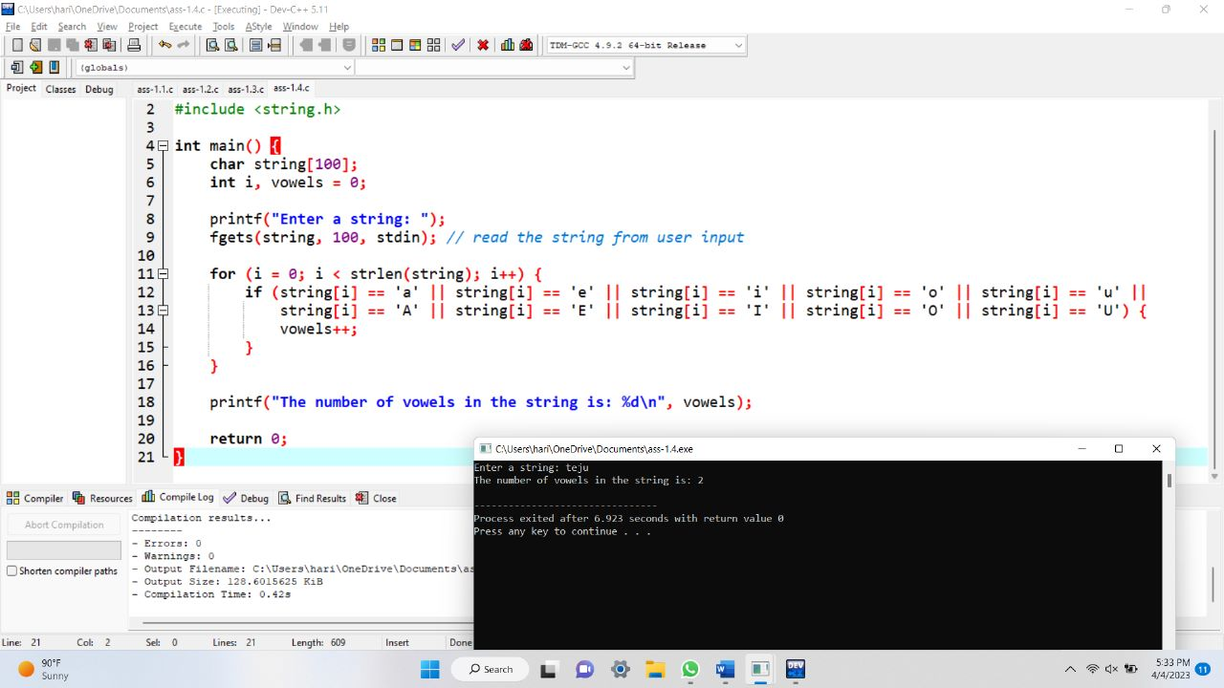

5.Write a C program to input character from user and check whether character is uppercase or lowercase alphabet using if else. How to check uppercase and lowercase using if else in C programming. Logic to check uppercase and lowercase alphabets in C program

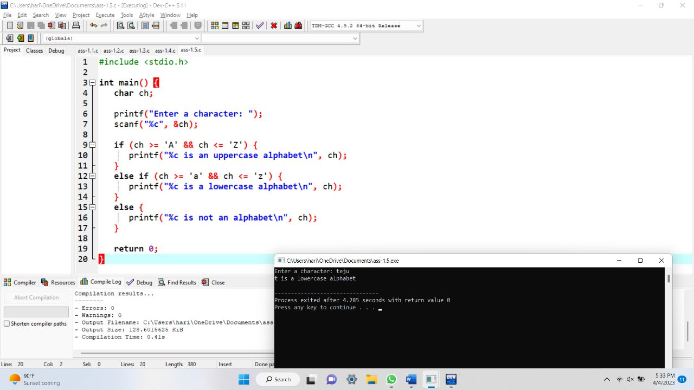

6.C Program to Check Armstrong Number

Armstrong Number in C: An Armstrong number is an n-digit base b number such that the sum of its (base b) digits raised to the power n is the number itself. Armstrong numbers are 0, 1, 153, 370, 371, 407, etc.

Armstrong Number Formula: wxyz = pow(w,n) + pow(x,n) + pow(y,n) + pow(z,n)

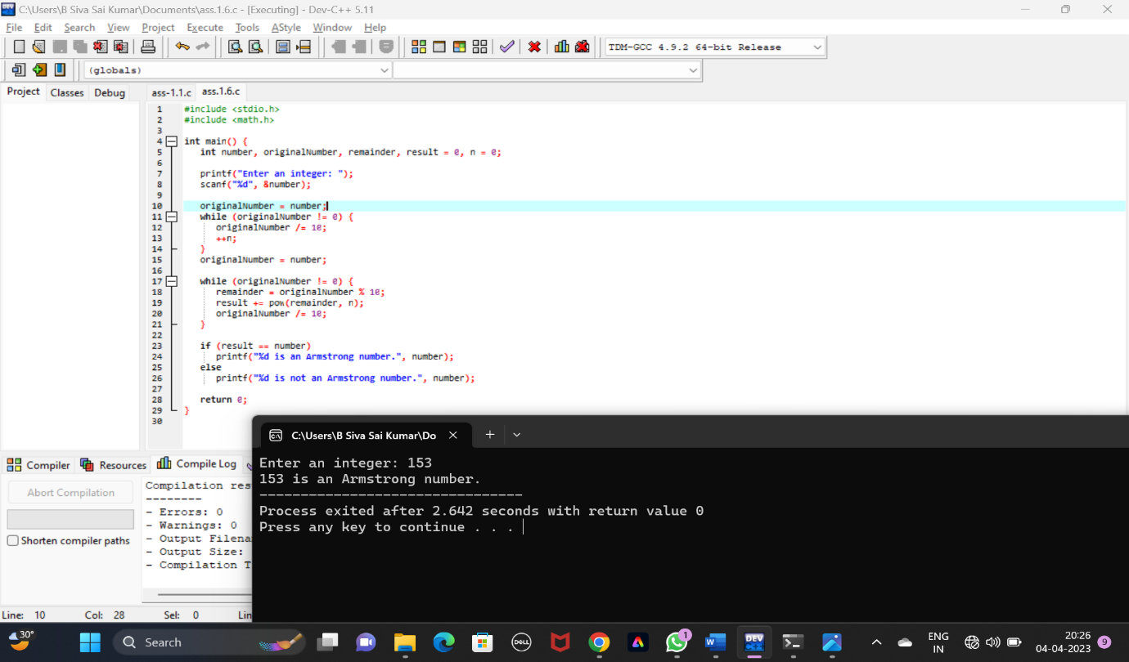

7.Write a C program to input a number from user and count number of digits in the given integer using loop. How to find total digits in a given integer using loop in C programming. Logic to count digits in a given integer without using loop in C program.

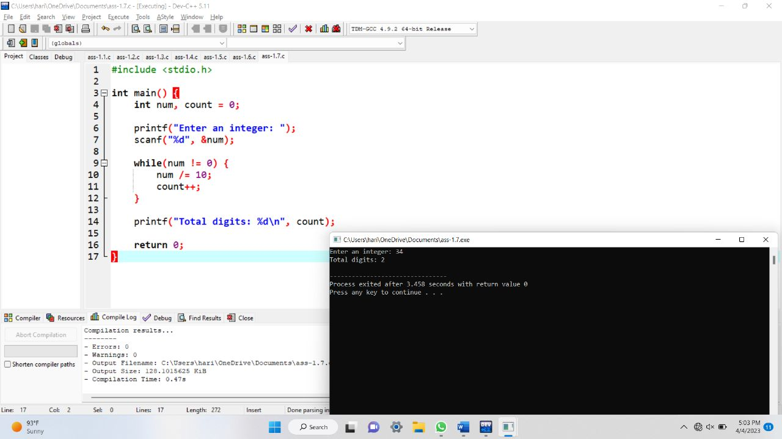

8.Write a C program to input a number and calculate sum of digits using for loop. How to find sum of digits of a number in C program. Logic to find sum of digits of a given number in C programming

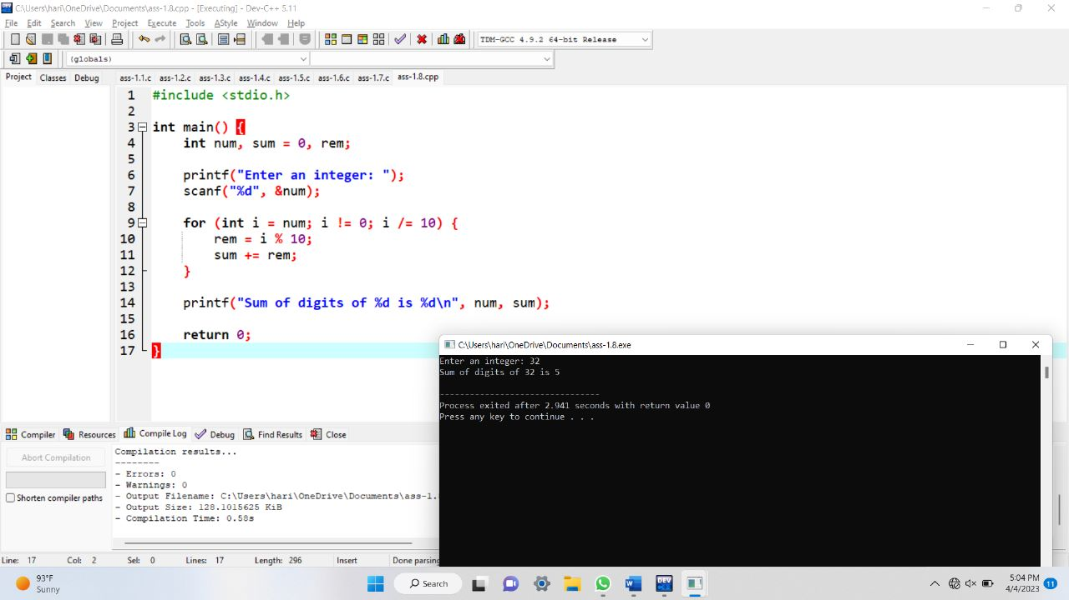

9.Write a C program to input a number from user and find reverse of the given number using for loop. How to find reverse of any number using loop in C program.

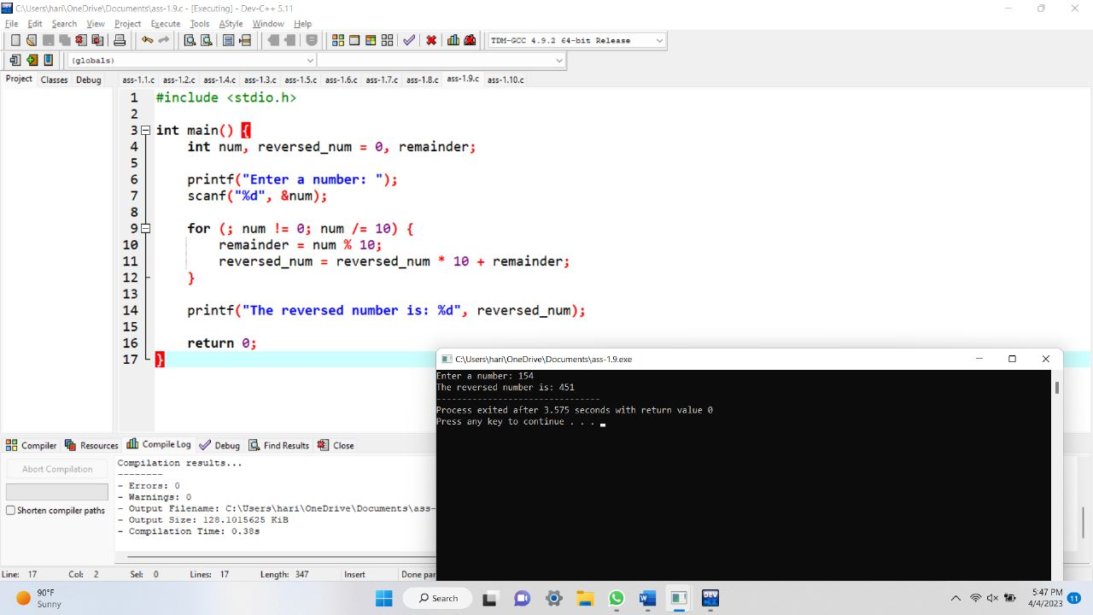

10.Sum of First N Natural Numbers in C

Write a C program to find the sum of first n natural numbers.

Formula:

Formula to calculate the Sum of First N Natural Numbers are (n \* (n + 1))/2.

